Course Code: |  |  | : | AI244AI | Date | : | 23-07-2024
Semester |  |  | : | IV | Time | : | 12:00 – 1:30 PM
Max Marks |  |  | : | 50 | Duration | : | 90 mins
Artificial Intelligence and Machine Learning
CIE II
Note: Answer all the Questions
SL. No |  | Questions |  |  |  |  |  | M | BT | CO
1 | a | Discuss the five components of a well-defined AI problem.  Ans: (Each carries 1 M with a brief description and examples)  - Initial State  - Actions  - Transition table/action description  - Goal Test  - Path Cost |  |  |  |  |  | 5 | 2 | CO1
 | b | Give a well-defined problem definition for the 8-Queens problem.  Ans: (Each carries 1 M with a brief description)  - States: Any arrangement of 0 to 8 queens on the board is a state.  - Initial state: No queens on the board.  - Actions: Add a queen to any empty square.  - Transition model: Returns the board with a queen added to the specified square.  - Goal test: 8 queens are on the board, none attacked |  |  |  |  |  | 5 | 2 | CO5
2 | a | Discuss the application of Breadth First Search (BFS) in a travel route planning application.  Ans:  - Use of the graph data structures for modeling the locations map (1M)  - Defining the Goal State (1M)  - BFS Algorithm: (3M)  - Use of Queues to store the locations  - Maintaining the visited locations information  - Start from a given location in the front of the queue  - Check if this is the required location. If yes, the Goal is reached  - If not, enqueue the reachable locations from the given location  - Mark the current location has been visited and repeat the steps until all the locations available on the map are explored |  |  |  |  |  | 5 | 3 | CO2
 | b | Differentiate between Depth First Search (DFS) and Depth-limited Search (DLS). Web crawling systematically searches the World Wide Web to index and collect website data. Which of the two DFS and DLS suits this purpose, and why?  Ans: Any 2 differences like, working principles of searching techniques and the time/space complexity. (2M)  DLS is suitable (1M)  Correct justification like avoiding infinite crawling (2M) |  |  |  |  |  | 5 | 3 | CO2
3 | a | For the given data set shown in Table 3a., find whether (20,35) belongs to class Red or Blue using the KNN neighbor. Assume K = 5.  Table 3a  Brightness Saturation Class  40 20 Red  50 50 Blue  60 90 Blue  10 25 Red  70 70 Blue  60 10 Red  25 80 Blue  20 35 ???? |  |  |  |  |  | 5 | L3 | CO1
 | b | For the given dataset shown in table 3b. (use logistic regression)  Table 3b.  Hours Study Pass (1)/Fail (0)  29 0  15 0  33 1  28 1  39 1  - Given the class, how can we calculate the probability of passing for the student who studied 33 hours?  - At least how many hours a student should study to ensure he will pass the course with a probability of > 95%.  - Assume the model suggested by the optimizer for the odds of posing the course is log(odds) = -64+2*hours. |  |  |  |  |  | 5 | L3 | CO2
4 | a | Consider the given dataset, apply the naïve Bayes algorithm, and predict that if a fruit has the following properties, then which type of the fruit it is Fruit = {Yellow, sweet, long}  Frequency table:  Fruit Yellow Sweet Long Total  Mango 350 450 0 650  Banana 400 300 350 400  Others 50 100 50 150  Total 800 850 400 1200 |  |  |  |  |  | 06 | L4 | CO5
 | b | With neat sketches, explain Bagging and Boosting ensemble learning techniques. |  |  |  |  |  | 04 | L2 | CO1
5 |  | Consider a training dataset of 6 data instances shown in Table 5. Use four decision stumps for each of the four attributes. Apply the AdaBoost algorithm and classify the dataset with job offers as the target attribute.  Table 5  CGPA Interactiveness Practical Knowledge Comm skills Job profile  >=9 Yes Good Good Yes  <9 N G Moderate Y  >=9 N Avg M N  <9 N Avg G N  >=9 Y G M Y  >=9 Y G M Y |  |  |  |  |  | 10 | L4 | CO5
M-Marks, BT-Blooms Taxonomy Levels, CO-Course Outcomes
Marks Distribution | Particulars | CO1 | CO2 | CO3 | CO4 | CO5 | L1 | L2 | L3 | L4 | L5 | L6
 | Max Marks CIE | 14 | 15 | - | - | 21 | - | 14 | 20 | 16 | - | -

Course Outcomes: After completing the course, the students will be able to:-
CO1 | Explain and apply AI & ML algorithms to address various requirements of real-world problems.
CO2 | Design and develop AI and ML solutions to benefit society, science, and industry.
CO3 | Use modern tools to create AI and ML solutions.
CO4 | Demonstrate effective communication through team presentations and reports to analyze the impact of AI and ML solutions on society and nature.
CO5 | Conduct Performance evaluation, modeling, and validation of AI and ML solutions benefitting lifelong learning.
Q. No | Scheme and Solutions | M
3a. | d1= (√ (20-40) ²+(35-20) ²) =√ (400+225) = √625 = 25, d2=√ ((20-50) ²+(35-50) ²) = √ (900+225) =√1125= 33.54, d3=√ ((20-60) ²+(35-90) ²) =√ (1600+3025) =√4625 = 68.01  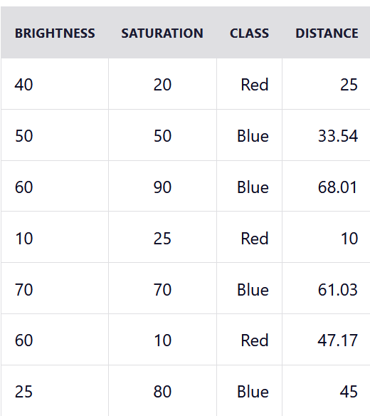  Let's rearrange the distances in ascending order:  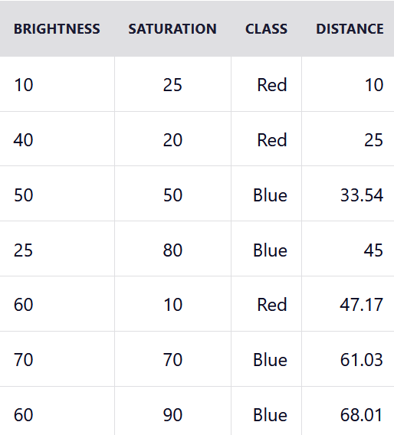  Since we chose 5 as the value of K, we'll only consider the first five rows. That is:  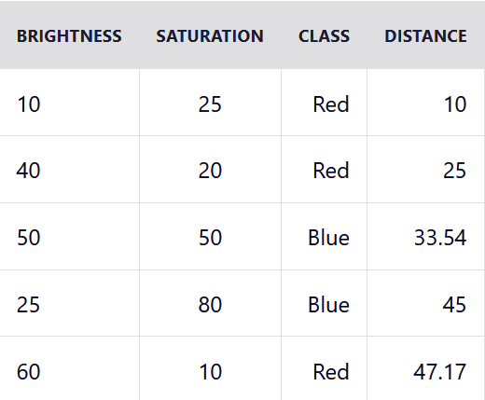  As you can see above, the majority class within the 5 nearest neighbours to the new entry is Red. Therefore, we'll classify the new entry as Red. | 05
3b. | 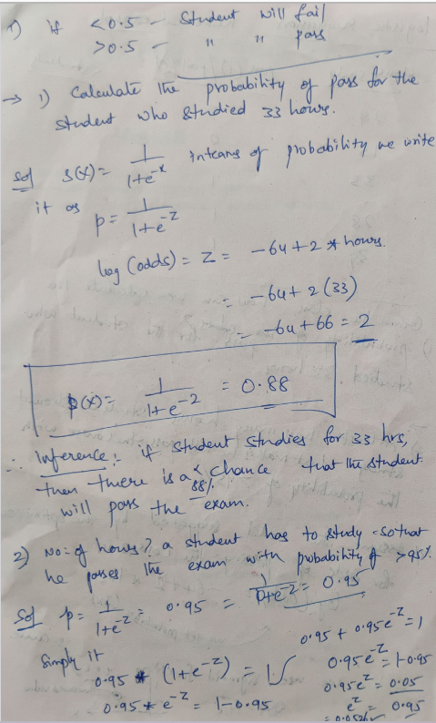  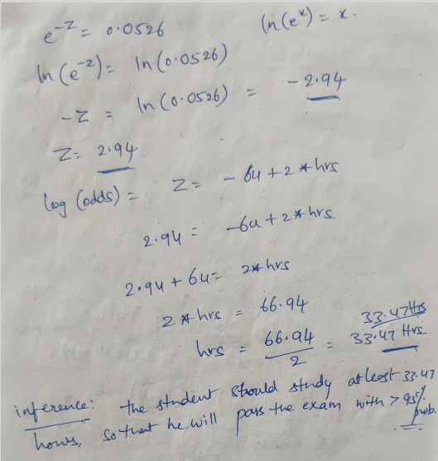 | 05
4a. | 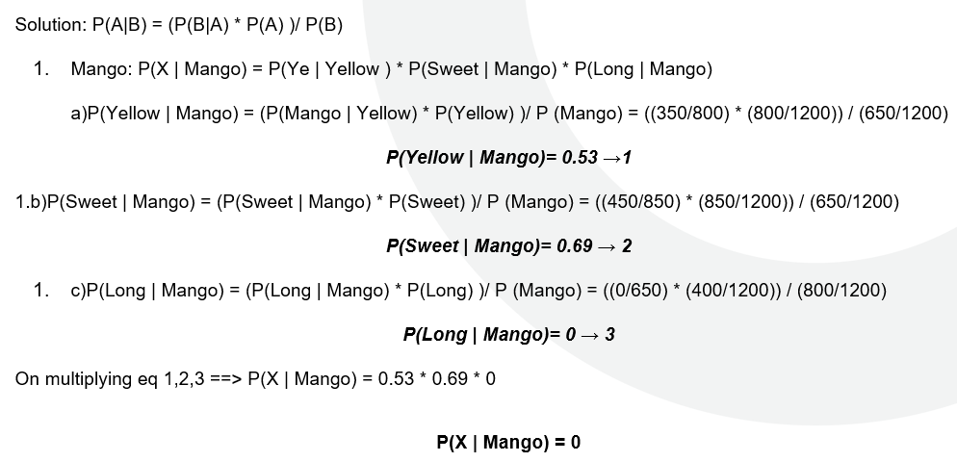  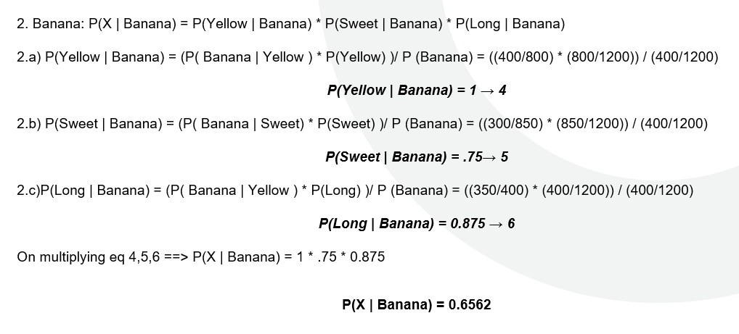  P(X|Mango) 2 M, P(X|Banana) 2 M, P(X|Others) 2 M  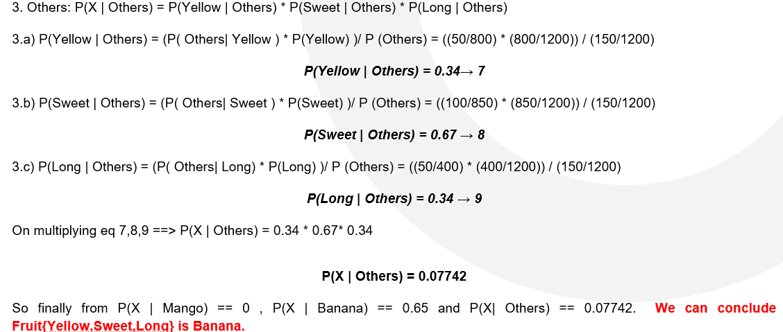 | 06
4b. | Bagging (Bootstrap AGGregatING)  - Bootstrap method is used to create multiple subsets of training data set and then train multiple base models separately on these bootstrapped training set to get different predictions from these base models.  - The final prediction is obtained by averaging or voting on the predictions from these base models.  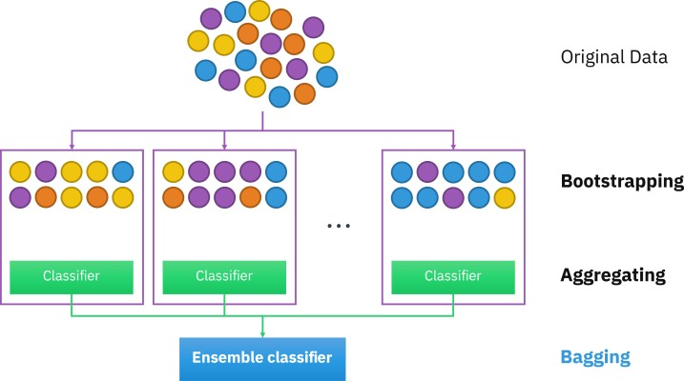  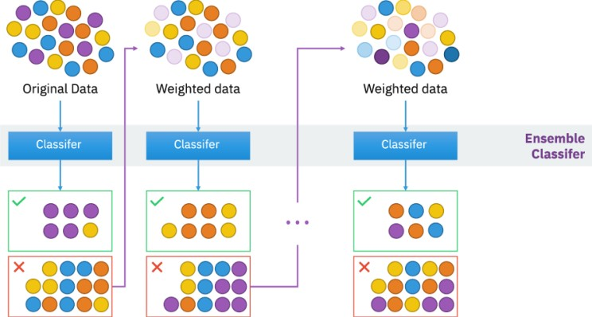  Boosting:  - Boosting uses the entire training data set in a sequential manner to improve the performance of weak learners.  - First, using the whole training data set to fit on a weak leaner.  - Then, according to the prediction results to adjust the weight of each observation in the training data set.  - Giving lower weights to those were classified correctly, while giving higher weights to those were classified incorrectly.  - Fitting a new weak learner on this modified data set.  - The sequential process of adjusting weights and predictions continues until a stopping criterion is reached.  - The final prediction is a weighted result of all weak learners. | 04
5 | 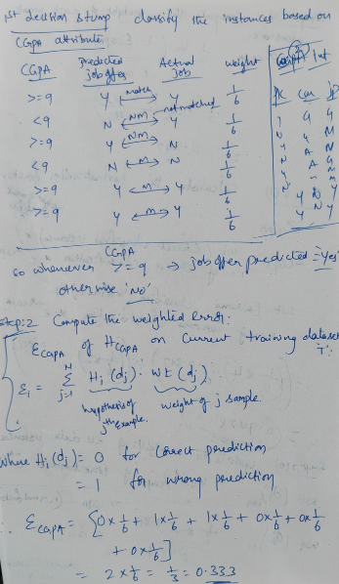  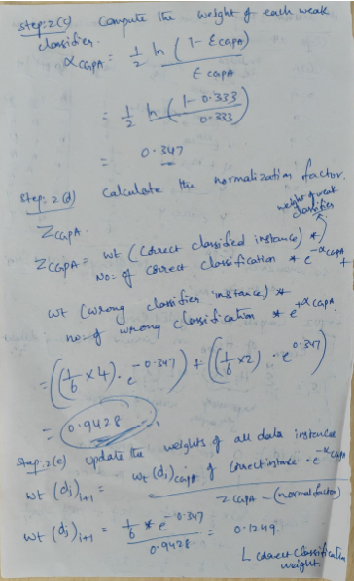  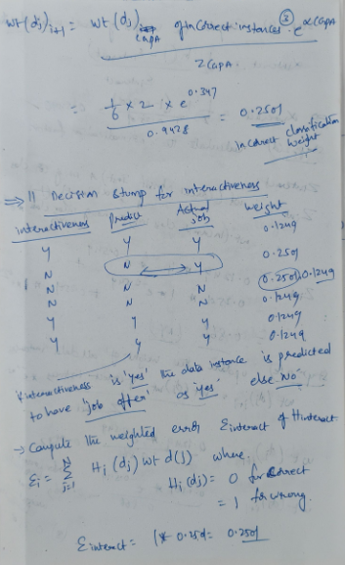  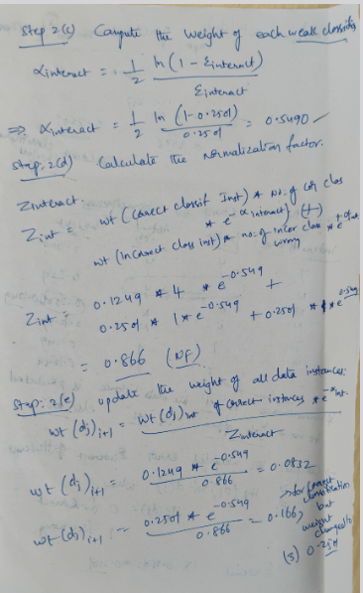  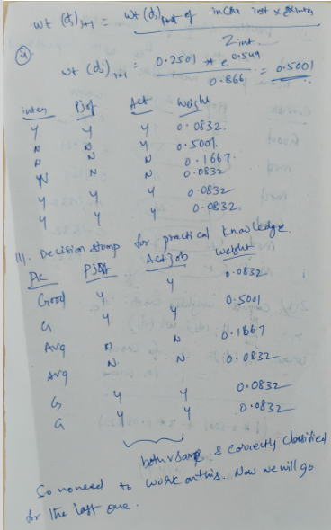  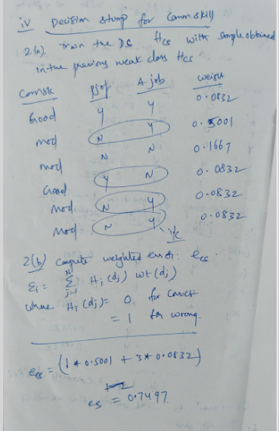  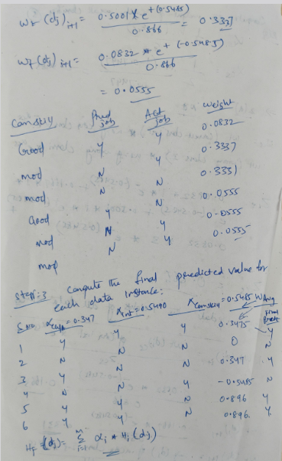  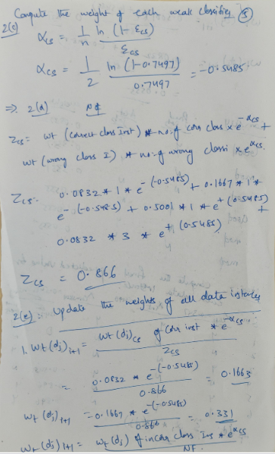  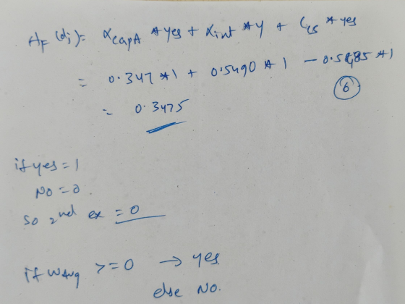 | 10

